St. Joseph’s Restorative Inquiry
Summer 2021 Newsletter

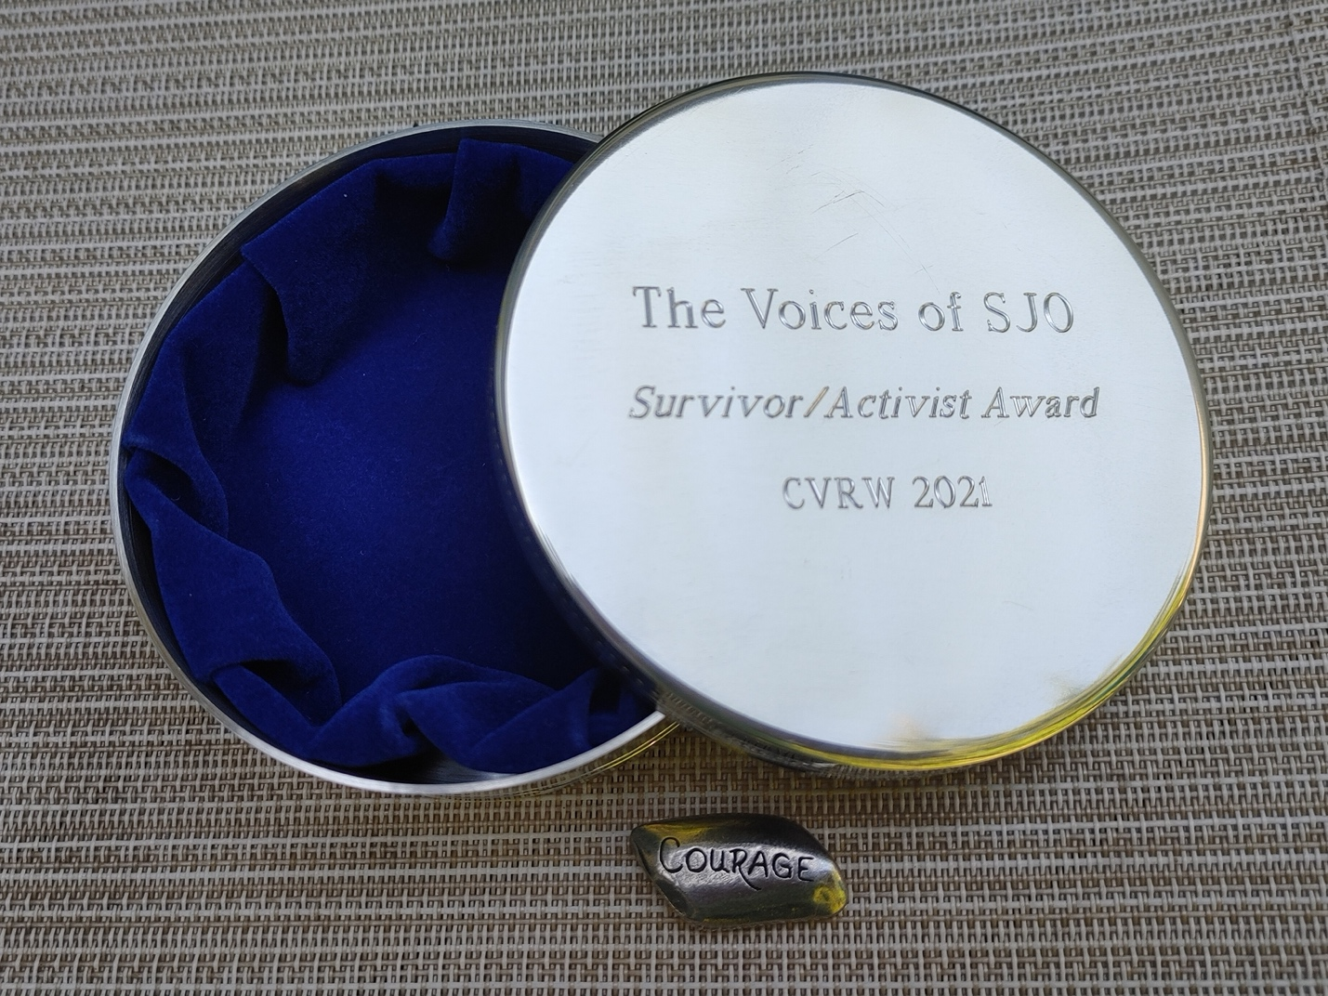
The Voices of St. Joseph’s Orphanage group receives the 2021 Survivor Activist Award!

Overview:
This is the fourth newsletter from the St. Joseph’s Restorative Inquiry (SJRI). SJRI seeks to understand and document the events of the orphanage through the voices, experiences, and stories of those most impacted (former residents); and then facilitates inclusive processes of accountability, amends-making, learning, and change.

The Restorative Inquiry is a project of the Burlington Community Justice Center. The project was launched in May of 2019 with funding and support from the Vermont Center for Crime Victim Services and is guided by an Advisory Team comprised of community stakeholders, restorative justice practitioners, and former St. Joseph’s Orphanage residents.

Restorative Inquiry participants meet every Friday from 11:00-1:00. The weekly meetings allow participants to connect with each other, share perspectives and experiences, and make decisions.
Current News and Initiatives:
In addition to the weekly meetings, the Restorative Inquiry is facilitating a series of initiatives that reflect the consensus-approved goals of the participants. The following is a summary of current news and initiatives:
- Awards! On May 1, the Voices of St. Joseph’s Orphanage group received the 2021 Survivor/Advocates Award from the Vermont Center for Crime Victim Services (see photo). The Center recognized the group for their work on behalf of all victims of institutional abuse, and their efforts to protect present and future children. Voices spokesperson, Brenda Hannon, accepted the award on behalf of the group. Several Restorative Inquiry participants also spoke during the online ceremony. In addition to the group’s award, Marc Wennberg, facilitator of the Restorative Inquiry, received the 2021 Ally Award at the same event. You can watch the full awards ceremony here.
- Changing the Statute of Limitations on Physical Abuse: On May 12, 2021, Governor Phil Scott signed legislation which removed the statute of limitations on physical abuse in civil proceedings. The Governor’s signature was the culmination of the Voices of St. Joseph’s Orphanage group’s months-long effort to change the statute, including their testimonies with both House and Senate Judiciary Committees. The change to statute, which was one of the group’s core goals, received considerable press attention. The participants’ deeply compelling testimony was cited as one of the key drivers of the remarkably swift passage of the legislation.
- Fall Gathering: The participants of the Restorative Inquiry are looking forward to gathering at the Windjammer Hotel in Burlington, Vermont, from September 14th-16th. The participants are planning a series of events over the course of the two days, including, among other activities: a tour of the future Memorial/Healing Space on the former grounds of the Orphanage, a public reading by the Writers’ Group, a Listening and Reflection Session for Department of Children and Families staff, a Press Conference, and a gathering of supporters and stakeholders to the Restorative Inquiry. This event is supported, in part, by the Vermont Center for Crime Victim Services.
- Working with the Vermont Department of Children and Families: Participants of the Restorative Inquiry are collaborating with staff from the Vermont Department of Children and Families (DCF) on several initiatives. The common goal of each of these initiatives is to ensure that children in state care never again experience the harms experienced by the former children of St. Joseph’s Orphanage. As is mentioned above, a group of participants are collaborating with DCF representatives to design and deliver a Listening and Reflection Session for DCF staff at the fall gathering. The session will be filmed so that future staff can also learn from the experiences of the Restorative Inquiry participants.
- Writer’s Group: The St. Joseph’s Orphanage Restorative Inquiry Writers’ Group is putting the finishing touches on an anthology of their writings. The book will be released to the public by the end of this summer and will be available for purchase ($20). The Writers’ Group (comprised of six Inquiry participants and facilitated by writer, Carol Adinolfi) also recently held an online reading of their work for Vermont Legislators and project stakeholders. As is mentioned above, the group will hold an in-person reading in Burlington during the September gathering.
- Memorial: The group (and a subcommittee) are working with the City of Burlington Parks, Recreation and Waterfront Department to establish a public memorial on the former Orphanage grounds (and now owned by the City of Burlington). The purpose of the memorial is to recognize the countless children who passed through and were impacted by the Orphanage, and create spaces for reflection and rest. At the most recent meeting, Parks staff presented a variety of memorial design concepts for the group to consider. Participants then completed a feedback survey to both reflect on the proposed concepts as well as brainstorm additional ideas. In July, Parks staff will present the next round of concepts to the subcommittee.
- Oral History Project and Exhibition: The group is partnering with the Vermont Folklife Center to record participant’s oral histories. To date, Vermont Folklife staff have recorded six interviews. Once the interviews are complete, each participant will decide how their recordings are shared (if at all) with the public, and when their recording is made available. In addition to the full recording, which will be archived at the Vermont Folklife Center, full interviews or excerpts may also be used (with person’s permission) in exhibitions, and on the St. Joseph’s Orphanage Restorative Inquiry website.
- Traveling Exhibition: On May 28th, the Restorative Inquiry received the exciting news that the project was awarded a $5000 grant from the Vermont Humanities Council to design and implement a traveling exhibition. The Voices of St. Joseph’s Orphanage Exhibition will chronical the history and impact of the Orphanage through the experiences, voices, and stories of the Inquiry participants. The exhibition will be developed in collaboration with the Vermont Folklife Center and will feature selections from the participants’ oral history recordings; a broad historical narrative and timeline of the Orphanage, and the participants decades-long fight for justice; historic and present-day photographs of both Orphanage and participants; and select artifacts and memorabilia. The participants will be the primary curators of the exhibit, and will have full authorship over their personal contributions.

How to get involved:
- If you are a former resident of St. Joseph’s Orphanage and would like to participate in the Restorative Inquiry, please contact Marc Wennberg at: marc@communityreentry.net or by calling 802-522-7394.

