St. Joseph’s Restorative Inquiry
January 2021 Newsletter

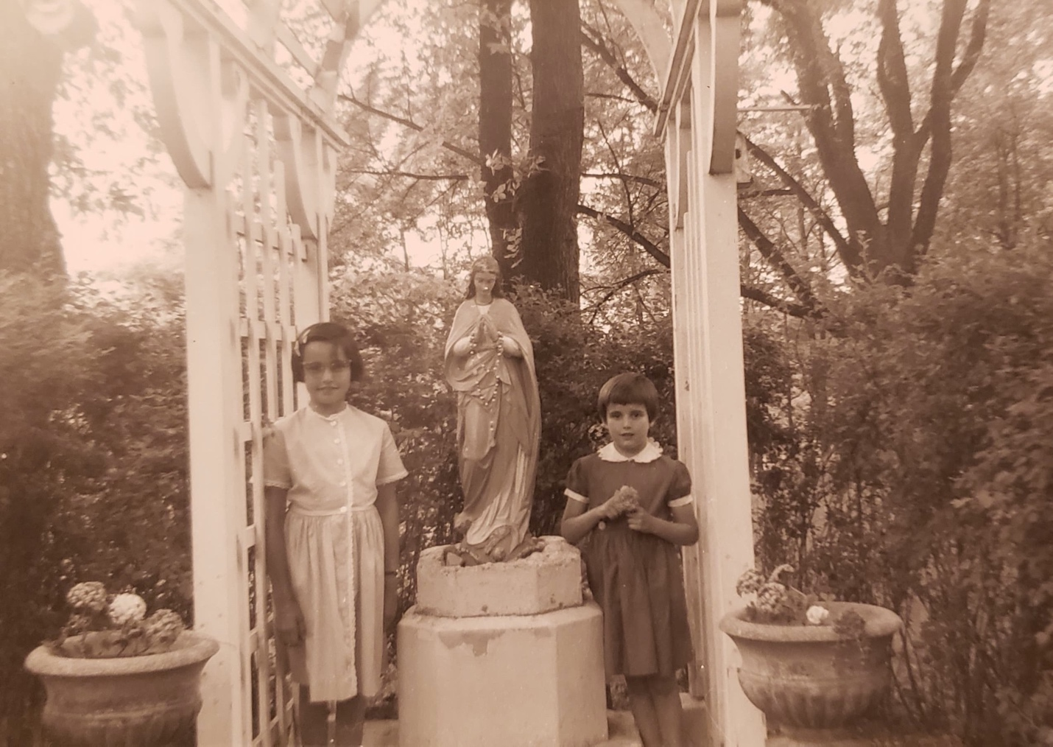
St. Joseph’s Orphanage, Circa 1950

Overview:
This is the second newsletter from the St. Joseph’s Restorative Inquiry (SJRI). SJRI seeks to understand and document the events of the orphanage through the voices, experiences, and stories of those most impacted (former residents); and then facilitates inclusive processes of accountability, amends-making, learning, and change. Restorative Inquiry staff are committed to facilitate and respond to the stated priorities and requests of the former children of St. Joseph’s Orphanage.

The Restorative Inquiry is a project of the Burlington Community Justice Center. The project was launched in May of 2019 with funding and support from the Vermont Center for Crime Victim Services and is guided by an Advisory Team comprised of community stakeholders, restorative justice practitioners, and former St. Joseph’s Orphanage residents.

Restorative Inquiry participants meet every Friday from 11:00-1:00. The weekly meetings allow participants to connect with each other, share perspectives and experiences, and make decisions. If you are a former resident of the Orphanage and would like to connect with other former residents, please contact Marc Wennberg (contact information at the end of this Newsletter)

Current Initiatives:
In addition to the weekly meetings, the Restorative Inquiry is facilitating a series of initiatives that reflect the expressed interests and requests of the former residents. The following is a summary of current initiatives:
- Statement from Voices of St. Joseph’s Orphanage: The participants of the Restorative Inquiry have prepared a Statement to be released simultaneously with the release of the Task Force’s Criminal Investigation Report. The statement is an affirmation of the stories and experiences of the participants both during and after the Orphanage. It also includes a list of the group’s consensus goals and aspirations with the Inquiry. The Voices Statement along with a statement from the Restorative Inquiry and Attorney General can now be found on the project website: https://www.stjosephsrjinquiry.com/news
- Participant-Informed Historical Research Project: The Restorative Inquiry established a collaboration with Bennington College in the spring of 2020 in order to conduct a participant-informed historical research project. Bennington College students India Carter-Bolick and Gabriela Yadegari met with the former residents to explore what Orphanage-related questions that the group wanted answered. India and Gabriela then conducted research into these questions, connecting with a variety of sources (including former residents); compiling documentation and photos; and preparing both interim and final reports. They shared their research with the participants in June and August. A summary of their research and personal reflection statements are now available on the St. Joseph’s Restorative Inquiry website.
- Access to Department of Children and Families Family Files: Several participants of the Restorative Inquiry were placed at the Orphanage by the State of Vermont. These participants requested the opportunity to view all state information (without redaction) related to their time at the St. Joseph’s Orphanage. In order to respond to this request, the Department of Children and Families (DCF) collaborated with SJORI staff to first search state archives, and then share found records with the corresponding participants. If you are a former resident and are interested in learning if the State of Vermont found your family records, please contact Marc Wennberg.
- Medical Records: SJORI staff partnered with UVM Medical Center to search for any available medical records of participants from their time at the Orphanage. UVM Medical Center has distributed found records to corresponding participants. If you are a former resident and are interested in learning if the UVM Medical Center has any relevant medical records, please contact Marc Wennberg.
- Writer’s Group: In May of 2020, a group of Restorative Inquiry participants requested the opportunity to work together in a facilitated writers’ workshop. In response to this request, SJORI contracted the services of Carol Adinolfi to coordinate a 10-week writers’ group. Five former residents participated in the group and are now sharing their work via select online reading. Their written work is now available on the website. The Writer’s Group also recently received a new round of funding from the UVM Medical Center Sponsorship Program. The group, which includes four new participants in addition to the current five writers, kicks off on January 21, 2021, and will continue for ten weeks.
- Orphanage Memorial: A committee of participants of SJORI are working with the City of Burlington to establish a public memorial to recognize the countless children who passed through and were impacted by the Orphanage. The collaborative group is currently discussing possible locations and designs for the memorial.
- Meeting with Public Policy Makers: Participants of the Restorative Inquiry have a core request: that no child or vulnerable person ever again experience the harm that they experienced. The group is currently working with select Vermont state legislators and other public policy makers to share their experiences, knowledge, and aspirations; and then work together to impact policy and better protect all vulnerable people.

Upcoming Initiatives:
- Oral History Collaboration with the Vermont Folklife Center: In January 2021, interested Restorative Inquiry participants will begin recording oral histories of their experiences with the Orphanage. Each participant will decide how and whether their recording is shared with others and potentially, the general public. With participants’ permission and guidance, some of the recordings may form part of a multimedia exhibition.
- Reunion Event: If we achieve broad vaccinations against COVID-19, the participants of the Restorative Inquiry want to hold an in-person gathering later this spring. We will have updates on the prospects for this gathering in upcoming newsletters.

Other Items:
How to get involved:
- If you are a former resident of St. Joseph’s Orphanage and would like to participate in the restorative inquiry, please contact Marc Wennberg at: marc@communityreentry.net or by calling 802-522-7394.
- If you are a former resident of St. Joseph’s Orphanage and in need of support, you can connect with Amy Farr, Victim Advocate at the Vermont Attorney General’s Office at amy.farr@vermont.gov or at 802-279-1027.
- All other requests and questions can be directed to Marc Wennberg at: marc@communityreentry.net.

