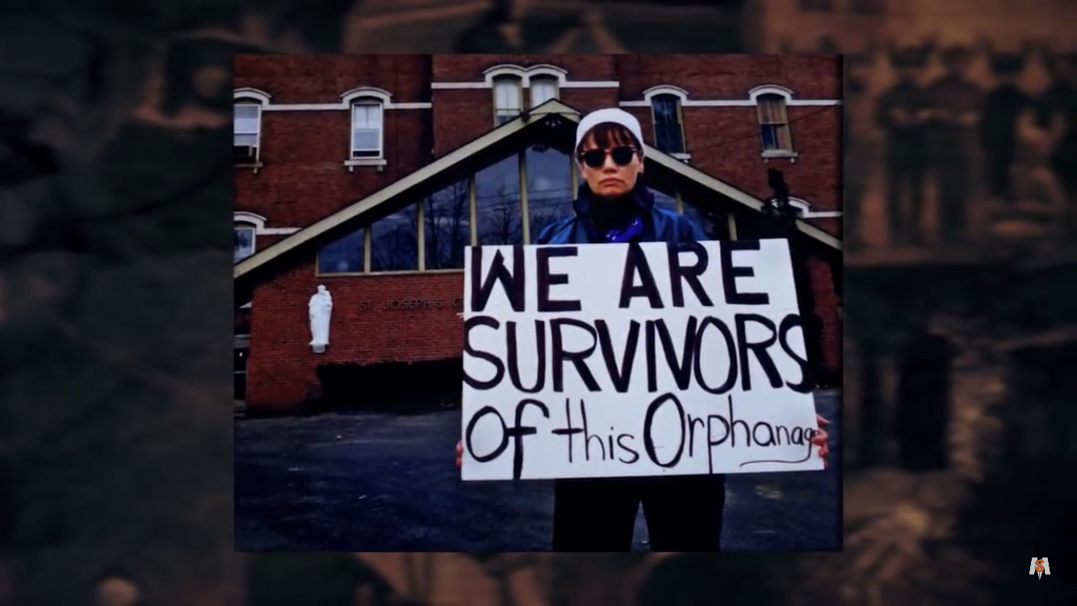

Please hear me out so you can choose how you feel.

When I was a child, I was stifled and unable to use my voice. I will never choose to be stifled ever again. We were treated the way we were because of politics, greed, and wrongful power. We didn’t matter then nor in the 90s. Not even now, waiting for the report is waiting for the elections to be over.

Y’all say you want to change the laws. I can’t ask people to care about what happened to me, when I am not being able to use my voice to speak for other children who are unable to use their voice. I have to share my truths and compassion for other humans. I don’t care what race they are or how they came here or where they’re from. They are children just like we were. I’m just so hurt at how this has to work.

I support good over greed, power, and hate. I first and foremost work for God. Politics and God are not two different things. I don’t care what anyone thinks says or feels about me. This is all my truth. I am a Seer and Prophet of God. I will build God‘s temple the way he intended men to have built it. To make sure man knows who makes God‘s laws, that man should live by. No one needs to fight about who is right and who is wrong, if one follows God‘s laws. With abortion, God is the only one that can judge of what a woman does with her body, not man. He is not without sin nor is any religion.

I know God talks and I hear him. From my beginning all of the miracles he has shown me. You don’t have to believe my faith in him but I do believe he will show you. This is a gift I gave to you from God: when you dream he will show you how frightened those children are, you will think you are one of them. The children taken from their parents because our misguided President, without human care, separated them, which is inhumane to do to a child or parent just for being frightened and running from fear.

Or for how frightened it would be to have someone kneel on your neck and you can’t breathe. Black Lives Matter. In your dreams is the way God speaks to you. You will have this if you don’t have compassion for another human. The list goes on of all Injustice that God wants man to fix.
What I say to the Catholic Church: as children we were beaten, tortured, molested, and some died. Secrets hidden for years and decades. In the 90s children came out and told the truth about their horrors in orphanages. And one can say, well all those people are deceased and gone. So you can’t have any justice. We were re-victimized by the people in the 90’s.

Everyone of those Nuns, Priests, etc. who would go into the orphanage as I picketed in the 90s, with their scowling faces. These are the same faces that I got as a child. How dare I speak and tell the secrets of the past. So telling me all those people are dead and that doesn’t happen anymore, I don’t believe you. I don’t believe anything ever changed even now picketing in the 2020.

The priest that spoke to me said we took care of all that in the 90s, but that was a lie. $5000 to $20,000 is not restitution for murder, molestation, and torturing of children for decades in orphanages around the world. I speak for only myself and say I want $150,000 from the diocese and Burlington. Also, Vermont paid the Diocese money for years to do a job and that was to help and care for children in need. The diocese needs to give back that money for not doing the job right, and all the generations of children that suffered because of their abuse That would be the right thing to do.

I want the right to ask because I’m giving you the chance to do the right thing or the wrong thing. The payment in the 90’s was a slap in the face. They just wanted us to go away and be quiet. No apology will ever be believed when I know that nothing has ever changed. I’ve seen this with my picketing.

My name is Coralyn

